LEX Program to Read a File and Add Line Numbers to Every Line

AIM:
To write a LEX program to read an input file and add line numbers to every line, displaying the numbered contents on standard output.\

PSEUDOCODE:
- Start the program.
- Initialize the line number to 1.
- Open input.txt in read mode.
- If the file is not found, display an error message and stop.
- Print the first line number.
- Read the file character by character.
- When a newline is encountered, increment the line number and print the next line number.
- Print all other characters as they are.
- Close the file and stop.
Program:
%{
#include <stdio.h>
int line = 1;
%}

%%
\n { printf("\n"); line++; printf("%d: ", line); }
. { ECHO; }
%%

int main()
{
yyin = fopen("input.txt", "r");

if (yyin == NULL)
{
printf("File not found\n");
return 1;
}

printf("%d: ", line);
yylex();

fclose(yyin);
return 0;
}

int yywrap()
{
return 1;
}

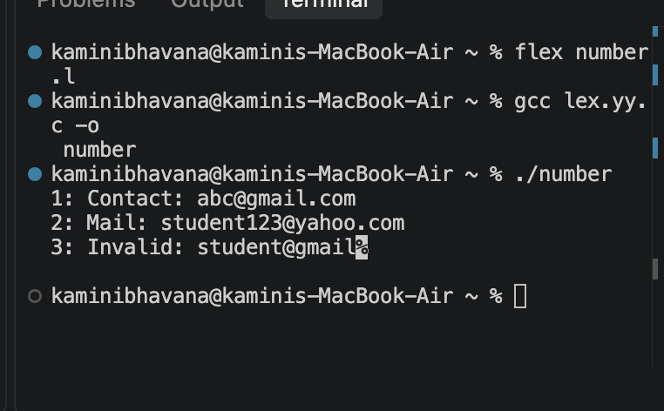
OUTPUT:

Result:
Thus, the LEX program was successfully implemented to read a file and display its contents with line numbers.

